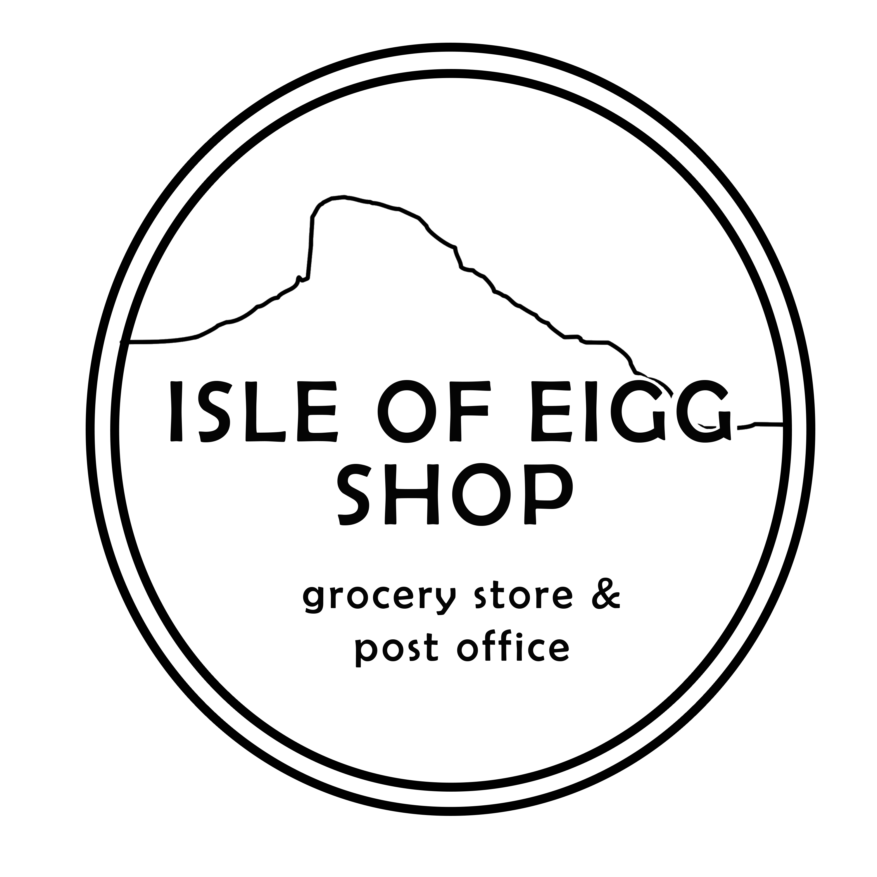

OPENING HOURS
29TH MARCH – 29TH APRIL 2019
21ST SEPTEMBER – END OCT 2019
(DEPENDENT ON CALMAC TIMETABLE)

OPEN CLOSE

MONDAY 10:00 17:00
TUESDAY 10:00 17:00
WEDNESDAY 11:00 15:00
THURSDAY 10:00 15:00
FRIDAY 10:00 17:00
SATURDAY 11:00 17:00
SUNDAY 15:00 16:30

POST OFFICE

MONDAY 10:00 12:00
THURSDAY 10:00 12:00
SATURDAY 12:00 14:00

If the ferry is cancelled, the shop will close at 15:00.

01687 482 432
info@isleofeiggshop.com
www.isleofeiggshop.com

